MEETING |  |  |  |  |  |  |  | 
Minutes of meeting n° 9 |  |  |  | 9 |  |  | 14/01/2026
Location : Penta Hotel City Center - Brussels |  |  |  |  |  |  | 14/01/2026
Distribution on 27/01/2025
Attendance | Present | Excused | Invited |  | Diffusion |  |  |  | Present | Excused | Invited | Diffusion
MO – Penta Hotel City Centre  Menno de Richemont | X |  | X |  | X | Contractor - NTSA  Thibault Fayd  Site supervisor (APO) |  |  | X | X | X  X | X  X
MOD – Immo-Pro (IP)  Olivier Fournier (OFO)  Leonardo Stefani (LST) – 0474/015.062 | X | X | X  X |  | X  X | Contractor – Pro4Finish (P4F)  Cedric Van der Burght |  |  | X |  | X | X
BET TS – TsfPlus  Grégoire Sillen |  | X | X |  | X | HSE coordinator – Whiteforge  Abdel Saifi |  |  |  | X | X | X
ARCH – De Bouwerij  Paul De Mulder  Iskra Bilic  Sofie | X  X |  | X  X  X |  | X  X  X | Contractor – Betico (BET)  Mourad Benja |  |  | X |  | X | X
BET – Concept Control (CC)  Benoit Lallemand | X |  | X |  | X

Next meeting :

21/01/2026 at 11 :00 – On site Chau. de Charleroi nr. 38, 1060 Brussels

C General

C1 Approval of the previous minutes of meeting

Néant

C2 Information exchange

From whom | Status | Content | Due date
IP | To send | Photo report of the staircase | 18/10
ARCH | To send | New compartmentation plans (first draft to be validated) | 31/01/2026

C3 Planning

Planning item
Level +5
- Floor back in service
Level +4
- 05/01/2026: Floor out of service
- 23/01/2026: Floor back into service
Level +3
- 26/01/2026: Floor out of service
- 13/02/2026: Floor back into service
Fire detection final audit
- Date to be confirmed (end of January)

D Discussed subjects

N° | Title | Subject – General | For whom | Due
07.01 | Planning | - New planning to be issued with additional details concerning the fire detection works and finishing works.  - New planning was issued on 10/12 | MOD | DONE

N° | Title | Subject – Sprinklers | For whom |  | Due
06.01 | ANPI | A visit with ANPI is scheduled on the 28/12 to review the current layout and remaining remarks.  - Following the visit of ANPI several informal remarks were issued. Those remarks will be taken into account in the quote of phase 2 of the works. |  |  | Pro memorie

N° | Title | Subject – Finishings/Architecture | For whom | Due
04.06 | Painting works level +7 | The painting works on level +7 will be carried out partly after the release of the level.  Pro4Finish will coordinate with the lobby to carry the necessary works in the rooms.  Meeting 27/11  - The finalisation of the works on level +7 will have to be carried out in the week of 15/12, while the fire detection is being renewed.  - The wall in the bedroom needs to be repainted, due to local damage during the installation of the sprinkler system in the following rooms: 711, 712, 715, 717, 718, 720, 721, 722, 724, 726, 729  Meeting 07/01/2026  - P4F will upload pictures of the finishing works executed on lvl +7 on the shared platform. | P4F  P4F | DONE  14/01/26
05.01 | Painting | - MO has sent photos of the painting works on level +7, which are not satisfactory. P4F will review and correct them.  - P4F will ensure that the subcontractor strictly adheres to the agreed execution dates going forward. | P4F | DONE
07.01 | Finishing works phase 2 | - MOD will send a quick recap of the works to be included in phase 2 of the finishing works  - ARCH and P4F will do the necessary site surveys to provide a bill of quantities  - P4F will provide a quote based on that bill of quantities  Meeting 07/01/2026  - Bill of quantities for phase 2 will be provided by the end of January.  - The relevant finishing details (ceiling mouldings) and colour propositions will be issued by 16/01/2026.  Meeting 14/01/26  - MO requests BOQ for the fire doors to be replaced according to the comments of the fire brigade to be separated from the rest to be able to order them asap. ARCH will do as requested. | MOD  ARCH | DONE  16/01/26
07.02 | Ceiling inspection hatches | Due to the installation of the new fire detection system, new inspection hatches are needed on the ground floor and level +8  - P4F has provided a unit price for 40x40 inspection hatches including the cut-out, provision and installation of the hatch. MOD has no remark on the unit price.  - The price of the inspection hatches will be included in the finishing works phase 2.  - The inspection hatches on the ground floor have already been cut out by the hotel staff (5 holes were cut out). P4F will install the inspection hatches by 05/12.  - The contractor Betico will provide a layout of the necessary inspection hatches on level +8.  - P4F will install the inspection hatches by Thursday 11/12 EOD, at the latest. Provided that the layout plan was sent before 05/06 to P4F.  - ARCH will provide a proposition for the painting works of the ceiling hatches (local detail) to prevent the necessity to paint the whole ceiling.  Meeting 07/01/26  - The inspection hatches will be finalized by 16/01/2026 on levels +8 and ground floor.  - Some (+-5) inspection hatches will need to be replaced by a 60x60 format instead of the 40x40 format. The structure above is not suited for the placement of the small format of hatches. | P4F  P4F  BETICO  P4F  ARCH  P4F | DONE  DONE  DONE  11/12  10/12  16/01/26
08.01 | Temporary fire doors and walls | On the request of the fire brigade, a temporary fire door and wall will be installed at the 15m limit in the corridor (dead end). The rooms behind this fire wall will be out of service until the end of the sprinkler works.  - P4F will provide a planning for the execution of the works  - The doors will be delivered on site around the end January/start of February  - The fire wall can already be executed while waiting for the doors (dates to be provided in the planning)  - The doors will not be painted. The additional options for the doors are not retained.  - The wall will be painted (same color as corridor) on one side only!  Meeting 14/01/26:  - Gyproc material for the walls is scheduled to be delivered on site on 20/01/26. Date to be confirmed. | P4F | 16/01/26
08.02 | Painting works +6 | - Painting works in the corridor on lvl+6 were finalized.  - Room 609: damaged wall still to be painted.
08.03 | Painting works +5 | Painting status of level +5 still needs to be assessed with the architect on site.  - P4F will upload the pictures on the shared platform

N° | Title | Subject – Fire detection | For whom |  | Due
08.04 | Fire detectors in the rooms | The fire detectors in the rooms are being replaced by fire detectors with integrated alarms.  The modification has started and will be finished by Wednesday 14/01/2026, depending on the availability of the rooms.  The fire detection system being modified on levels +2, +3, +4, +5, and +6 will be temporarily kept out of service until the 14th of January 2026 in order to prevent warnings on the central unit. The programmer will reinstate the system after the modification.  Meeting 14/01/26  - Programming will be organised Friday 16/01.
08.05 | Fire detection controls | Betico awaits the information on all the controls that need to be taken into account.  IP will follow up with the engineering office Concept Control to provide the necessary information.  Meeting 14/01/2026:  - List of fire detection controls will be setup by Betico and sent to IP and MO.  - Concept Control will provide the necessary information to complete the list and relevant actions in order to be compliant. |  | IP  BET  CC | 16/01/26  23/01/26  23/01/26
08.06 | Communication with central unit of the parking | IP will contact the parking to know the position of the central unit which needs to be connected to the central unit of the hotel.  Meeting 14/01/26:  - Betico will account for a cable (8-cables), that can be used by the parking as well which will prevent that the parking needs to place a separate cable. The change order will be sent as soon as the local measurements are done. |  | IP | 16/01/26
09.01 | Extra keys | MO has requested new keys for the fire central and “repetitor”. Betico will provide the price for those extra keys. |  | BET | 21/01/26

E. Appendices
Indications on plan, see sketch here under:
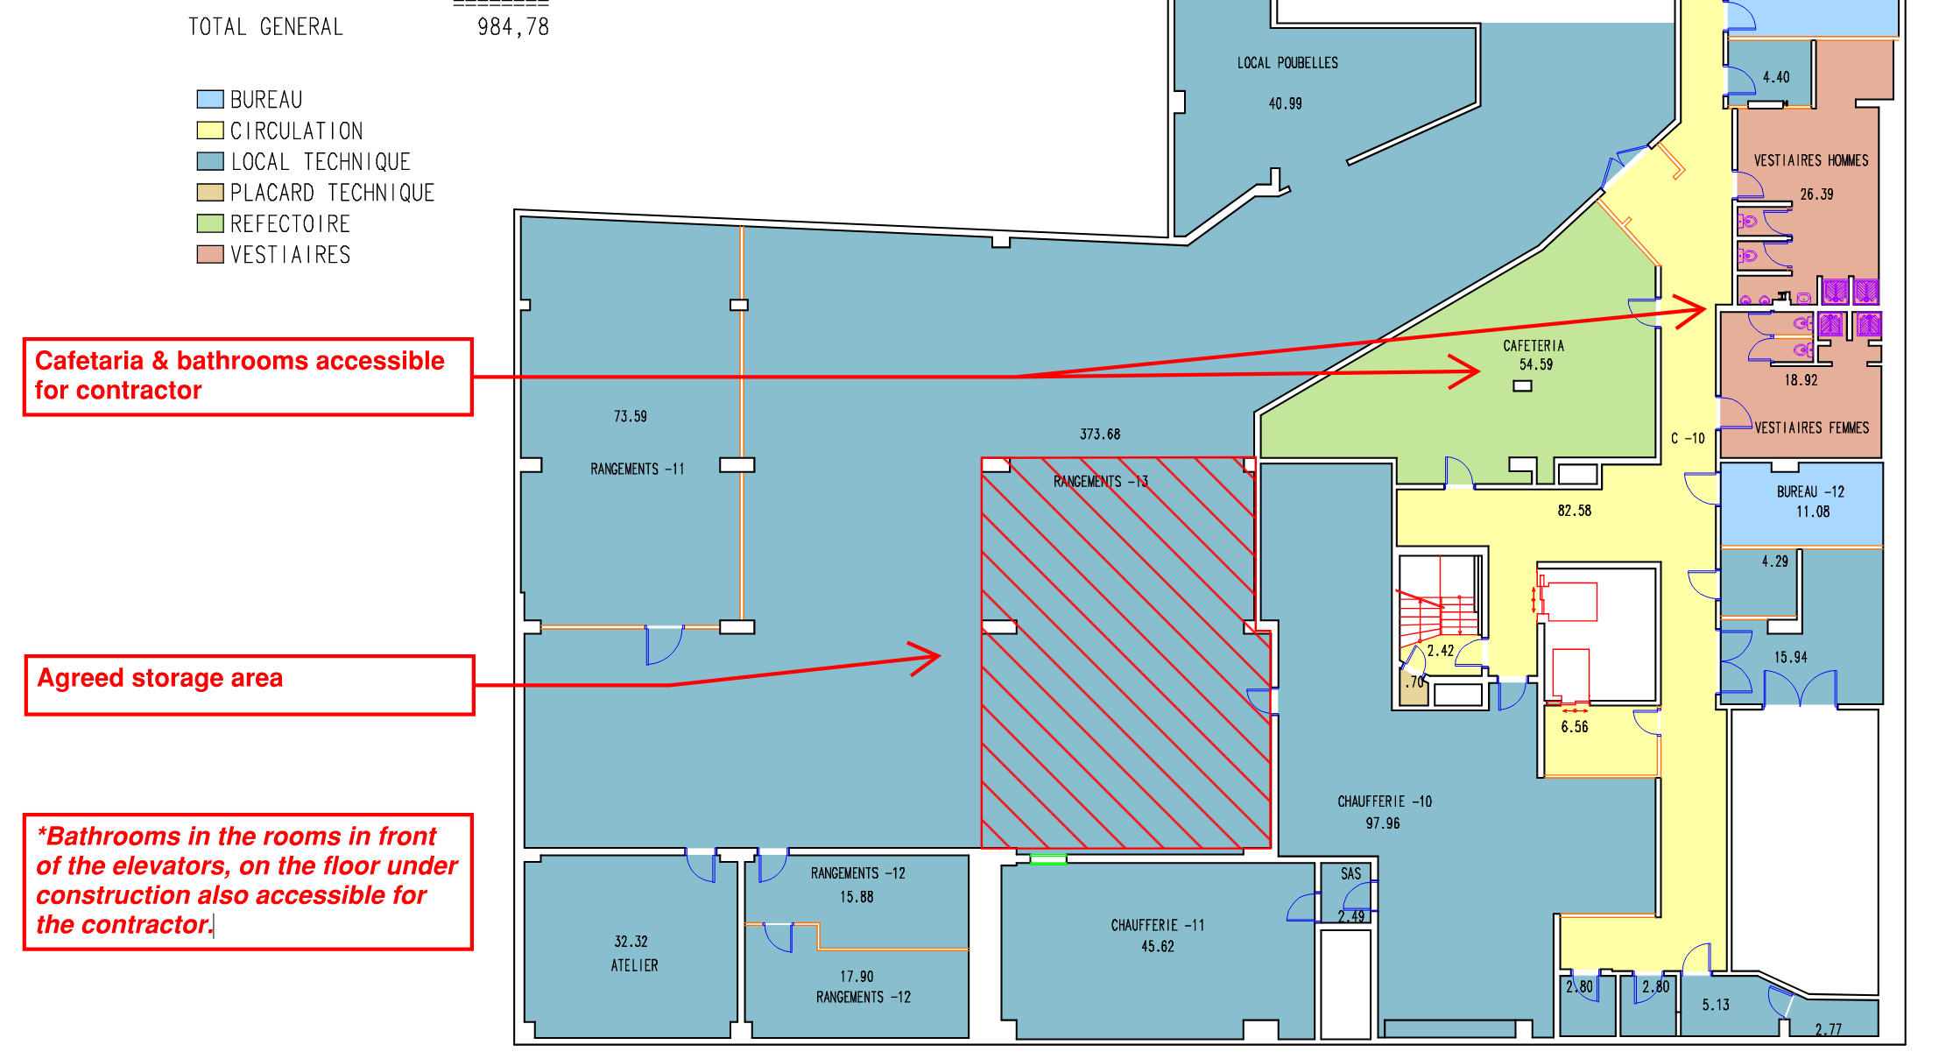

F. General remarks
This report will be subject to approval at the beginning of the next meeting; however, any corrections may be made upon receipt of it.

End of this report.

